OUR 107th (DIOCESE ACW MINI ANNUAL)
PROGRAM

THEME: Matthew 18:20 (NLT)
²⁰ For where two or three gather together as my followers, I am there among them.”
ONE DAY ONLY Saturday, June 1st, 2019
8:00 to 9:00 am—registration @ St. Matthew’s Church
(Beverage/muffins/fruit provided)
9:30 am -Business Meeting
(Will be collecting UTO offering)
12:00 NOON- Lunch provided
1:00- 3:00 pm - speaker Bishop David & certificates received
3:00 to 5 pm- Break
5:15 pm - Supper provided
6:30 pm – Entertainment - each branch is requested to have a skit, reading or song prepared
8:30 pm – Close with Evening Prayer

REMINDER:
- Bring your UTO collected
- Branch ACW year-end reports
- Financial reports & Branch forms
- Please Make sure you Circle what you want on the Supper menu
- Register ASAP by phone, email or regular mail

REMEMBER - Book of Remembrance forms need to be sent to Sheila!

PLEASE BRING ALONG
- Your own Thermo Beverage Cup

Thank-you and hoping to see you on the Saturday, June 1st, 2019

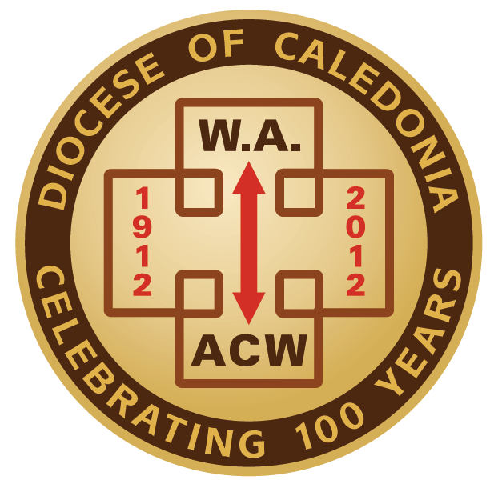
ANGLICAN CHURCH WOMEN
OF CALEDONIA
On behalf of the ACW Diocesan Executive. I am happy to extend an invitation to all Anglican Church Women to attend our 107th Diocese Mini Annual Meeting in Terrace. I urge each Branch and Parish to send their President or proxy and delegate where appropriate. Any Parish that does not have a formal ACW are also welcome to have ladies from their Church attend as well. We will be happy to see you all for this one day event.
Sister in Christ,
Susan Kinney
Past Diocesan ACW President

Mail to:
REGISTRATION FORM
Ingrid Whittington
4616 Woodland Park Dr.
Terrace, B.C. V8G OB6
Email: irwhittington@citywest.ca
Phone: 1 (250) 635-3139
Enclose: $15.00 Registration Fee

Name: ______________________________________
Address: ____________________________________
____________________________________________

I am: President: _________ Proxy: _______________
Voting Delegate: _________ Participant: __________
Branch or Parish: ____________________
Allergies: ____________________________
Special Diet:
* Number of family members we can expect
at Saturday Supper: _____
($15.00 per person)
*Supper Menu: Pizza, Salads, and Chicken wings
**Please Circle Type of Pizza wanted:
(Meat lovers) (Chicken) (Veggie) (Cheese lovers)
**Please Circle Type of Wings wanted:
(Boneless) (Bone In)
**Please Circle Type of Salad wanted:
(Toss salad) (Caesar salad)

Registration Deadline: May 15th, 2019

